**What is Excel? Why do we use Excel?**

MS Excel is a commonly used Microsoft Office application. It is a spreadsheet program which is used to save and analyse numerical data. MS Excel is widely used for various purposes because the data is easy to save, and information can be added and removed without any discomfort and less hard work.

Given below are a few important benefits of using MS Excel:

Easy To Store Data Since there is no limit to the amount of information that can be saved in a spreadsheet, MS Excel is widely used to save data or to analyse data. Filtering information in Excel is easy and convenient. Easy To Recover Data: If the information is written on a piece of paper, finding it may take longer, however, this is not the case with excel spreadsheets. Finding and recovering data is easy. Application of Mathematical Formulas: Doing calculations has become easier and less time-taking with the formulas option in MS excel More Secure: These spreadsheets can be password secured in a laptop or personal computer and the probability of losing them is way lesser in comparison to data written in registers or piece of paper. Data at One Place: Earlier, data was to be kept in different files and registers when the paperwork was done. Now, this has become convenient as more than one worksheet can be added in a single MS Excel file. Neater and Clearer Visibility of Information: When the data is saved in the form of a table, analysing it becomes easier. Thus, information is a spreadsheet that is more readable and understandable.

**List all the versions of Microsoft excel. Compare excel software provided from multiple vendors.**

Version 1: This first version of MS Excel was released in 1985 for Macintosh and it lacked many features.

Excel 2.0: Excel 2.0 was the first Windows version, which was released in 1987.

Excel 3.0: This was the third version of Excel, which was released in 1990. The third version was much more advanced as compared to the previous versions because it was upgraded with features like toolbars, outlining, add-in support, drawing capabilities, 3D charts etc.

Excel 4.0: The fourth version of Excel came with another useful feature called ‘auto-fill’ that enables the user to speed up the data entry process. Excel 4.0 was also regarded as the first popular version due to the addition of its new user friendly features. It was released in 1992.

Excel 5.0: The fifth version of Excel came with a major upgrade that is the inclusion of Visual Basic for Applications (VBA) and it helped to automate various excel tasks. This version became insecure and was affected by macro viruses due to the automation functionality. Since these macro viruses was not detected by anti-virus software, it became a huge problem. But later, several measures were taken by Microsoft to solve this issue.

Excel 95 (v7.0): This was one of the important and stable versions of MS Excel after Excel 5.0. It was released in 1995 and was much faster compared to its previous versions.

Excel 97 (v8.0): This is a more advanced version of excel and it is used as standard VBA in place of internal excel basic. It was included in Office 98 and used flight simulator as an Easter egg.

Excel 2000 (v9.0): Excel 2000 came with many features like HTML companion file format, web-based collaboration and data sharing options, drag and drop features etc. It also featured auto fill option and that facilitated quick analysis of data.

Excel 2002 (v10.0): Excel 2002 came with some outstanding features like voice dictation and voice-activated commands. It enabled the user to perform actions and tasks through voice commands.

Excel 2003 (v11.0): The 11th version only had some minor upgrades and the introduction of new tables was important among them.

Excel 2007 (v12.0): Excel 2007 was the most stable and widely used version of MS Excel. It introduced more user friendly interface, advanced chart and graph, XML file format options etc.

Excel 2010 (v14.0): Excel 2010 was more advanced and came with several features like improved pivot tables, upgraded formatting options, limited image editing options etc. Moreover, it offered 64-bit support and many new formulas.

Excel 2013 (v15.0): This version included many advanced tools like Flash Fill, Power View, Windows App, Timeline Slicer etc, and is available with Office 2013.

Excel 2016 (v16.0): Excel 2016 is equipped with even more exciting features like Power Query Integration, Quick data linking options, new charts etc. and is available with Office 2016.

**How to create bar charts in excel, demonstrated with practical examples.**

1. Select the range A1:B6.

[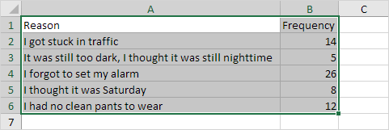](https://user-images.githubusercontent.com/88320437/155655387-7ade3743-2ec0-4831-91ab-2f153ad1af3e.png)

1. On the Insert tab, in the Charts group, click the Column symbol.

[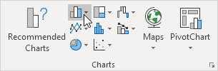](https://user-images.githubusercontent.com/88320437/155655436-1000e037-1ad5-4340-877d-d241a67a1f23.png) 3. Click Clustered Bar. [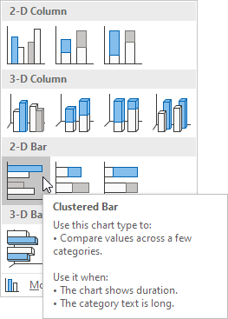](https://user-images.githubusercontent.com/88320437/155655485-1d3cefa6-d9ce-4469-a3b9-f7a444272f4e.png)

Result [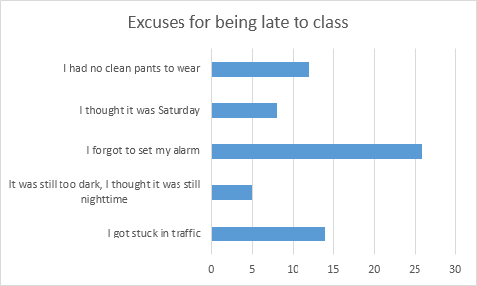](https://user-images.githubusercontent.com/88320437/155655510-69180e6e-7107-4540-87bb-8e001ebfa02d.png)

**How to connect Excel with the databases.**

1.Open your workbook in Microsoft Excel. Excel comes with a feature called Power Query (also called Get & Transform) that makes it easy to connect to an Oracle database.[1] 2.Click the Data tab. It’s at the top of the screen. 3. Click Get Data. If you don’t see this option, click New Query instead. 4. Click From Database. 5. Click From Oracle Database. 6. Enter the Oracle server name into the ″Oracle Database″ box. This should be the host name or address of the server that hosts your database. If the database requires an SID, use this format to type the server name/address: servername/SID 7. Enter a native database query (optional). If importing data from the database requires a specific query, expand the ″SQL Statement″ box by clicking the small triangle, and then type the statement 8. Click OK. This saves your options and initiates a connection to the database. 9. Log into the database. If the database requires you to log in, enter your username and password, and then click Connect. This connects the workbook to the database. Depending on your settings, you may also have to choose an authentication method. If you entered a native database query, the results will appear in a Query Editor window. Click From Oracle Database. 6.Click Get Data. If you don’t see this option, click New Query instead.